**Tutorial on Deploying Web Services into ASU WebStrar Server**

**Foreword from CSE445/598 Instructor – Yinong Chen**

Creating a Web server for a large class is unprecedented because of the complexity, the security concern of ASU ETS Department, and the cost of setting up and maintaining such a server. With numerous attempts and long hours of collaborative work between ETS staff, CSE tech director (Lincoln), my TAs, and myself, we managed to get such a job done for the first time in Spring 2009. I owe all of them for their tireless effort and for having the server up and running. Numerous problems occurred in the first implementation in Spring 2009. The service is becoming better every year. I expect that this semester will be even better. However, I urge all of you for your patience if the sites are slow or is not working as well as we have planned and wished. Our Blackboard is managed by the professionals and it still have occasional downtimes. We cannot expect our WebStrar to be available all the time. Please plan ahead and do not try to submit the assignment in the last day or in the last minute. Right now, the ETS person in charge of WebStrar server support is Shaun Usman, shauntu@asu.edu.

Please use the site responsibly at all the time and report any problems to me and to the TA immediately.

**Table of Contents**

1. WebStrar Server and its Sites 1

2. Setting Up File on Windows 7 4

3. Setting Up File Sharing on Windows XP 7

4. Setting Up Web.config File for Public Access 13

5. Issues shared among students: 13

# WebStrar Server and its Sites

The Web server **WebStrar** is set up based on the current technology of Server on Demand (SoD) based on virtualization and cloud computing concepts. WebStrar supports multiple independent sites, and its individual sites are <http://webstrarX.fulton.asu.edu/pageY>, where, X should be replaced by the site number 1, 2, 3, …, N that has been assigned to your team. Each site has 11 pages: page0, page1, page2, …, page10, as shown in the following figure.



Each group in CSE445/598 will be assigned a server site, and each member will be given the access to all the 11 pages (folders) in the site assigned. The team members can decide how they want to use the pages.

The suggestion is to use page0 for deploying the group pages, such as the main page that contains the description and the table of services. Each member can use up to three pages for deploying the individual services. In each page, you can deploy multiple Web services (service operations) or Web applications. Each member must plan properly to pack all the required services and elective services into three papers. If you have three members in the team, each member should have at least three folders. How do you deploy all your services into the three folders? You can use one folder for the TryIt test pages, one page for the required services, and one page for the elective services. You can wrap multiple services (operations) into one service, with each service containing multiple operations.

You can access each page from in a Web browser. For example, if the site number is X = 15 and the page number is Y = 7, you can access the application deployed in the site at:

<http://webstrar15.fulton.asu.edu/page7/Default.aspx>

Notice that. these 11 folders (pages) have been converted into IIS Application folders that support .svc services and ASPX applications by the administrator in ASU ETS. We only have the FTP access the servers, and we cannot remote login to administrate the servers. Thus, please NEVER delete any pre-created folders/pages in the site. They are registered with WAS. If you delete a folder, your service will never work, even if you recreate the folder. The recreated folder is NOT registered to WAS. The entire site may need to be reset in order to restore the site. It may take a few weeks for ETC to complete the additional task, bepending on the length of the job queue at ETS.

When you deploy the service, you do not deploy the service-root folder. You copy the files and sub-folders in the service-root folder into one of the pre-created folder.

All the web services and web applications deployed into the server are accessible by the public. The services you deployed into WebStrar may be copied to another permanent server at ASU, as WebStrar will be reset for the next class at the end of the semester. You will still be the owner of the services and applications, but the services will be accessible by the public for free forever. If you do not want your services to be copied into another server at the end of the course, you must let the TA know and we will have the services deleted.

Before you put your Web services or Web applications into the server, you should test them on your own IIS (or at least on your .Net Development server. In order to know if your IIS work, you need to test your IIS by putting a simple application in the IIS. For example,

1. You can put the following index.html file IIS wwwroot folder. You can also place the same file into the WebStrar root folder and the other pages (page0 through page7) folders where you plan to deploy your services:

<html>

<B>Today is a good day</B>

</html>

1. Then, you can put the following Default.aspx file with an embedded computation statement into the folders:

<html> <body>

Hello CSE445/598<br>

<B><% Response.Write(DateTime.Now.ToLongDateString())%> is a good day</B>

</body> </html>

You can use any text editor to type this code and name it Default.aspx.

WebStrar support .Net Framework 4.5 applications. Use Visual Studio 2012 to create your .Net Framework 4.5 applications.

**VPN Connection**

To install ASU VPN:

Enter MyASU --> My Apps --> Search VPN

You will find:  [**Cisco Anyconnect SSLVPN**](https://webapp3.asu.edu/myapps/Search/0/VPN#quicklinkContainer1139). Install and enter the connection address: sslvpn.asu.edu

Then, you can use your ASU RITEID to connect.

# Setting Up File on Windows 7

This section provides instructions to set up file sharing under Vista and Windows 7. The method use is called **Map Network Drive (MND)** method. DO NOT any other method to transfer files to the server.

1. Select **Computer** from the *Start* icon to open the “Computer” folder where you can see your C drive, etc.
2. Select the **Computer** in the left panel and then you see "Map network drive" in the tool bar, as shown in the figure below. Click on "**Map network drive**".

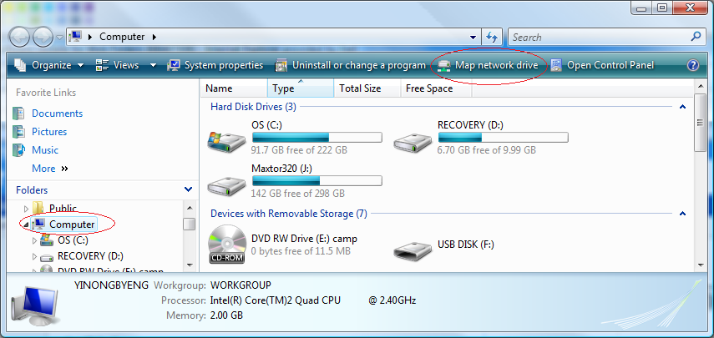

1. As shown in the "**Map Network Drive**" dialog, click on the "Connect to a Web site that you can use to store your documents and pictures" link.

The network address likes the form:

\\[webstrar.fulton.asu.edu](http://webstrar.fulton.asu.edu)\websiteX, where X = 1, 2, 3, …, N

You should replace X with the site number assigned to your group.

1. Type a name for the network location.

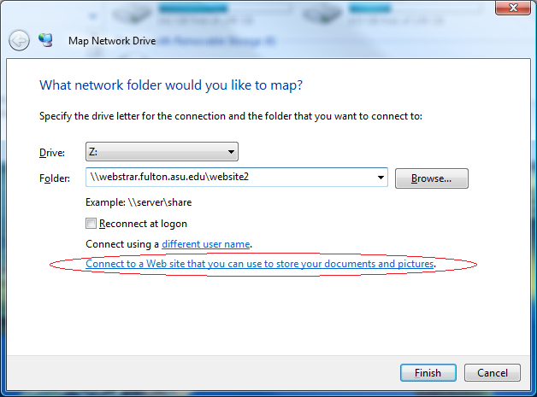

Double click to “Choose a custom network location”:

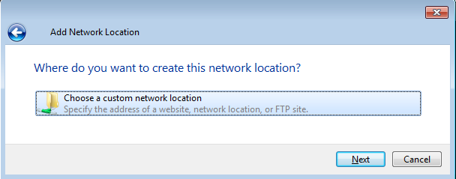

Enter the address again:

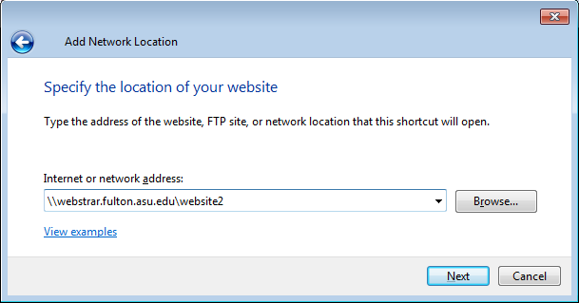

You will be asked to enter your ID and password. Assume your ASURITE ID is doe14, then, you should enter asuad\doe14, as shown below.

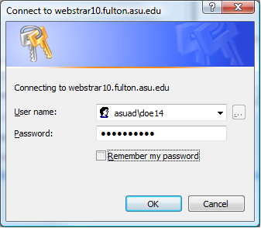

* + To maintain security, **do** **not** check "Remember my password."
  + **Note:** You may be prompted to enter your User name and password two or three times.

Once you see the files, you are connected to the server site.

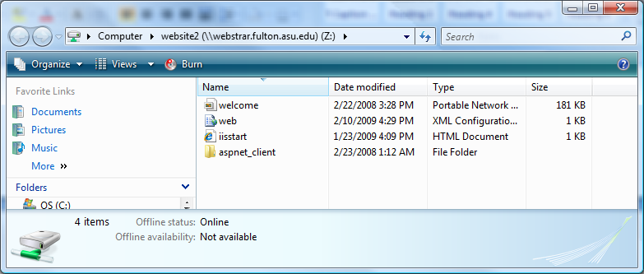

## Service Publishing and Deployment

The folders page 0, page1, …, page10 have been converted to application and are registered to WAS of IIS. DO NOT delete these folders. You copy your service files into one the folders.

Deploy Pre-Compiled Code

* + Choose “Build 🡪 Publish Web Site 🡪 Choose location File System option. Do not choose publish to server option.
  + Choose a location and a folder, e.g., “PreComplierService” outside your project folder to publish the files.
  + Copy (Deploy) **the files** in the folder PreComplierService into a pre-created folder in WebStrar, such as page0, page1.

## HTTP Status Code Error Message

A server normally have different restrictions and limitations from you localhost. If you receive an error when accessing the services that you have deployed in the server, you can check the HTTP status code and error message code at: http://support.microsoft.com/kb/943891

For example:

400 - Bad request. The request could not be understood by the server due to malformed syntax. The client should not repeat the request without modifications. This means that your request syntax, most likely, the way you express the variables, is incorrect. You must follow the UriTemplate that you defined in the operation attributes to make the request.

An error code can have sub code. For example, 404 is an error “Not Found”. If it gives sub code, it may have different meanings. For example:

404.13 - Content length too large,

404.14 - Request URL too long,

404.15 - Query string too long

Some of limitations, such as input and output sizes, can be defined in the service or application configuration. You can change the value to bigger value.

<requestLimits maxAllowedContentLength="1000000" />

# Setting Up File Sharing on Windows XP

The principle of setting up the connection to the server in XP is same as that in Vista and Win 7. However, the process is slightly different. This part of the tutorial will show you the process for XP.

* Open the control panel and find "**My Network Places**"

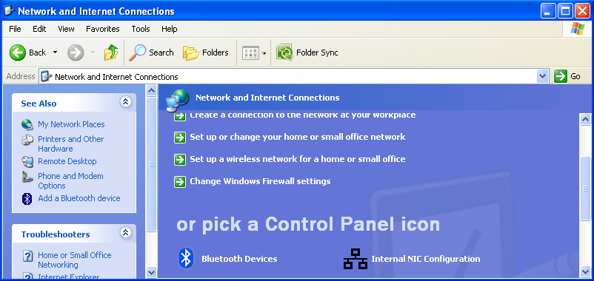

* Click "**Add a network place**" from the left-hand navigator bar under "Network Tasks".

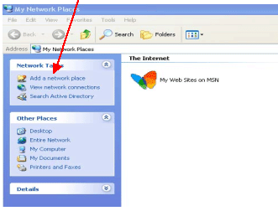

* Click on the "**Next**" button to continue the process.

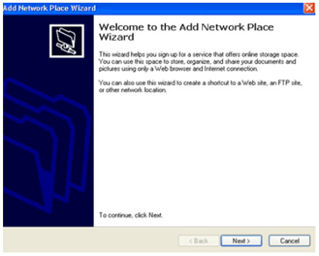

* The "Next" button directs you to the following screen. Click the "**Choose another network location**", and then press the "Next" button.

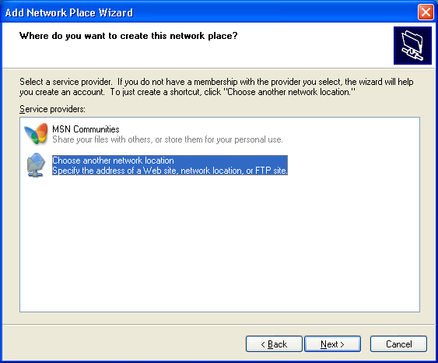

* Enter the URL of the network address and click next. For example:   
   \\[webstrar.fulton.asu.edu](http://webstrar.fulton.asu.edu)\website28

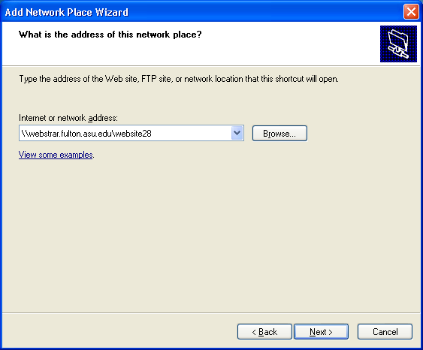

* You will be prompted to login using your **ASURITE id** and **password**. This is the same username and password you use to access your myasu. But you need add asuad\ before your username. For example, my username is doe14. I need to use ASUAD\joe14 as username.



* + To maintain security, **do** **not** check "Remember my password."
  + **Note:** You may be prompted to enter your User name and password two or three times.

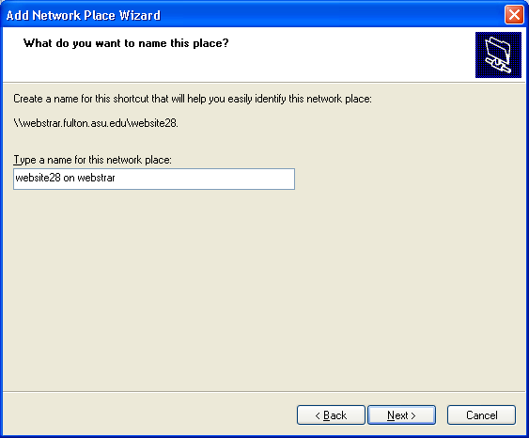

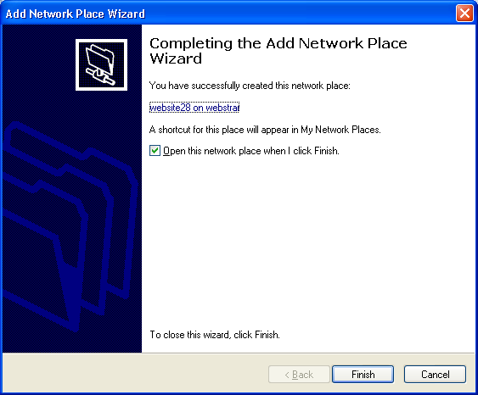

* Click "**Finish**" to complete the creation of the network place.
* You may be prompted to login again with your ASURITE ID and password.
* When you Press the "**OK**" button, all the files inside your web site will be listed.

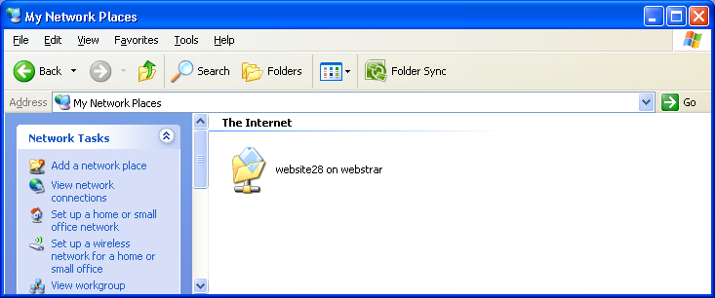

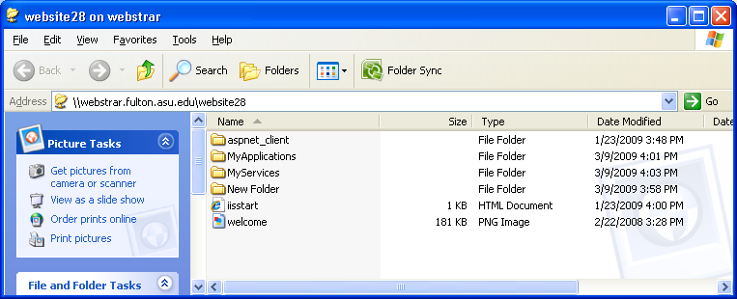

* Now you have completed your WebDAV installation. You can drag the course folder onto your desktop if you want it to be easily accessible.
* Now you can drag any files or folders from drives on your local computer. We suggest that you create your files and folders on your computer, instead of within the WebDAV folder.
* If you want to delete your course folder, click on the folder, and while pressing the "shift" key, press the "delete" key on your keyboard.

Please create a page (folder) and put all files related to the service or application in this folder. You should not create a new folder as the root folder of you service or application, as the folder need to be registered to the administration service. However, you can create subdirectories in the predefined pages.

As a test, please deploy the myFirst.aspx page given in the lecture notes into page1 folder. Then, you can try to access the application by

http://webstrarX.fulton.asu.edu/page1/myFirst.aspx

# Setting Up Web.config File for Public Access

When you developing a Web service or a Web application in ASP .Net, a file called Web.config will be generated, which resides in the same directory as the service or the application. This file may contain the authentication and authorization settings of the Web service or a Web application, depending on the initial setting of your system. For both applications and services deployed into the web server, you may need to define the permission to the public by editing the Web.config file. You must change the setting from <authentication mode="~~Windows~~"/> to <authentication mode="Forms"/> and add an authentication clause <allow users ="*" />, as shown below.

<configuration>

<system.web>

<authentication mode="Forms"/>

<authorization>

<allow users ="*" />

</authorization>

…

</system.web>

</configuration>

We will discuss Forms-based security in Chapter 6.

For this assignment, you may also set <authentication mode="None"/>

Below are the instructions that guide you step by step to set up and access the Web server as a developer.

=============

# Issues shared among students:

Note, if your computer uses wireless to connect to the internet, the Map Network Drive may not connect. In this case, try to use a computer with cable connection.

--------------------

I finally got it to work yesterday but today the network drive was showing as disconnected.  I did a "net use /delete" (DOS command) and then I was able to map it again, but just doing a Windows disconnect didn't seem to work to allow to re-add. If you are having issues, try these DOS commands:  
"net use /delete \\webstrar.fulton.asu.edu\websiteXX" (XX is your site)  
"net use Z: \\webstrar.fulton.asu.edu\websiteXX /user:asuad\<ASURITE>"(XX is your site and <ASURITE> is your asurite id

--------------------

Do not use wireless connection when you connect to WebStrar. It does not connect reliably, if it connects all.